如何运行FreeCAD
1、Use the RS232 serial port terminal connection
The RS232 is defined as follows:
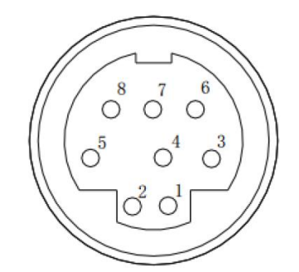
pin | definition
4 | RX
8 | TX
6 | GND

2、Use the CRT software
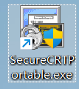
Set the baud rate, etc., and then click Connect
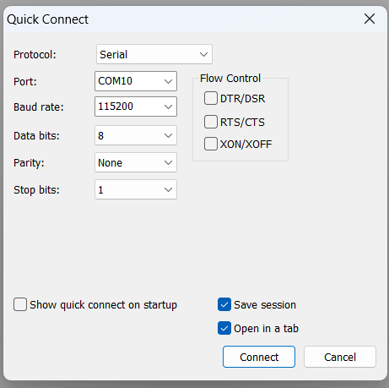
By entering Linux commands in the CRT software, one can control the machine.
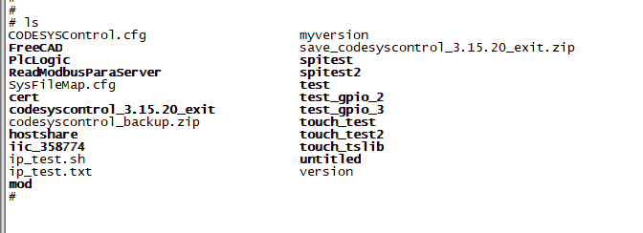

3、The computer needs to be set up to run Ubuntu, and the IP address should be set to 192.168.1.18. Connect the machine and the computer using a network cable.
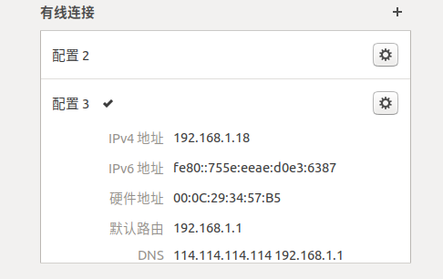
Extract the provided "test.zip" archive to the "/home/test" directory on Ubuntu.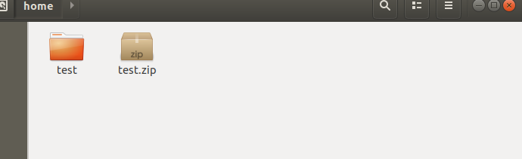
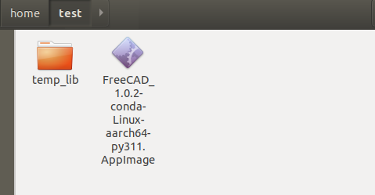

4、Enter the command in the CRT software:
busybox mount -o nolock -t nfs 192.168.1.18:/home/test /mnt/
You can mount the folders in Ubuntu onto the machine. You can use Linux commands like cp to
copy files onto the machine.
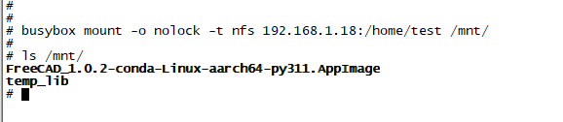

5、Enter the command to create a folder
mkdir -p /root/FreeCAD
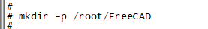

6、Copy the extracted FreeCAD_1.0.2-conda-Linux-aarch64-py311.AppImage software from Ubuntu to the /root/FreeCAD folder on the machine. Waiting for the transmission to complete.
cp /mnt/FreeCAD_1.0.2-conda-Linux-aarch64-py311.AppImage /root/FreeCAD/
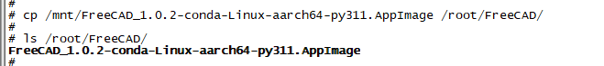

7、Enter the directory /root/FreeCAD/ and input the command to decompress the FreeCAD software
cd /root/FreeCAD
./FreeCAD_1.0.2-conda-Linux-aarch64-py311.AppImage --appimage-extract

8、Copy the "temp_lib" folder extracted from Ubuntu to the "/root/FreeCAD" folder on the machine.
cp -r /mnt/temp_lib /root/FreeCAD/
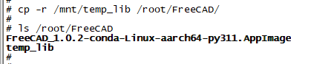

9、Enter the /root/FreeCAD/temp_lib directory and run the replace.sh script. Wait for the script to finish executing.
cd /root/FreeCAD/temp_lib
./replace.sh
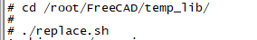

10、Enter the command to restart the machine.
reboot

11、After restarting, enter the following command to set the environment variables
export TSLIB_TSDEVICE=/dev/input/event1
export TSLIB_TSEVENTTYPE=input
export TSLIB_CONFFILE=/etc/ts.conf
export TSLIB_PLUGINDIR=/usr/lib/ts
export TSLIB_CALIBFILE=/etc/pointercal
export TSLIB_CONSOLEDEVICE=none
export TSLIB_FBDEVICE=/dev/fb0
export LD_LIBRARY_PATH=/lib:/usr/lib:/usr/lib/ts
export PATH=/bin:/sbin:/usr/bin/:/usr/sbin
export XDG_RUNTIME_DIR=/usr/lib/
export DISPLAY=:0
export QT_QPA_FONTDIR=/usr/lib/fonts
export QT_QPA_PLATFORM_PLUGIN_PATH=/usr/lib/qt/plugins
export QT_QPA_PLATFORM=xcb
export QT_QPA_FB_HIDECURSOR=0
export QT_QPA_GENERIC_PLUGINS=tslib:/dev/input/event1
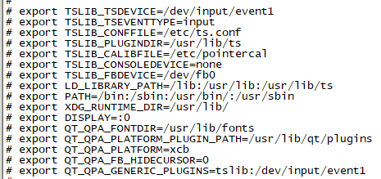

12、Enter the command to run FreeCAD
/root/FreeCAD/squashfs-root/AppRun &
